Standard scaling is a preprocessing technique commonly used in machine learning to standardize the features of a dataset. It transforms the data such that the mean of each feature is 0 and the standard deviation is 1. This is done by subtracting the mean of each feature from the data point and then dividing by the standard deviation of the feature.

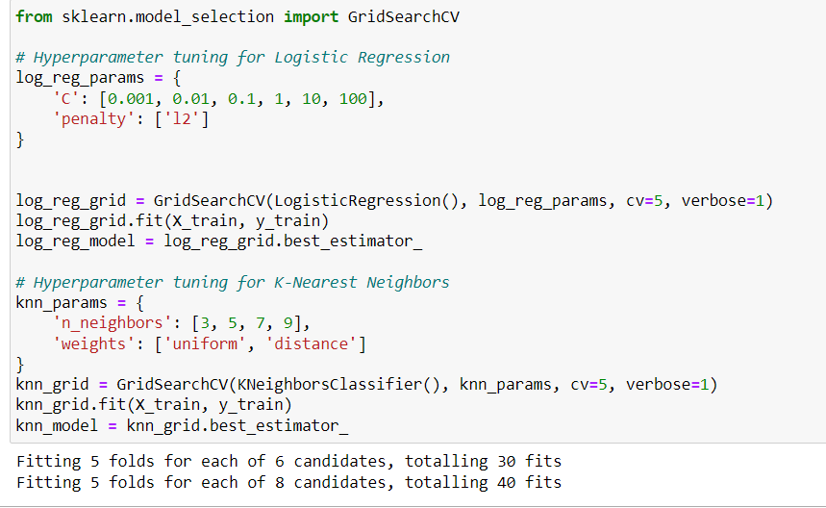

### For Logistic Regression:

1. **C**: This is the regularization parameter, which controls the inverse of regularization strength. Regularization is a technique used to prevent overfitting by adding a penalty term to the loss function. `C` is the inverse of regularization strength, so smaller values specify stronger regularization. It's a positive float, where smaller values specify stronger regularization.

2. **penalty**: This parameter specifies the norm used in the penalization. `'l1'` and `'l2'` are the options. `'l1'` penalty adds the absolute value of the magnitude of coefficients as a penalty term to the loss function, while `'l2'` penalty adds the squared magnitude of coefficients. Here, you're using `'l2'`, which is the most common choice and encourages smaller parameter values.

### For K-Nearest Neighbors (KNN):

1. **n_neighbors**: This parameter specifies the number of neighbors to consider when making predictions. It's an integer value. Increasing `n_neighbors` can smooth the decision boundary and reduce overfitting, while decreasing it can make the model more sensitive to noise in the data.

2. **weights**: This parameter specifies the weight function used in prediction. `'uniform'` assigns equal weight to all points in the neighborhood, while `'distance'` assigns weights proportional to the inverse of the distance from the query point. Using `'distance'` weights means that closer neighbors of a query point will have a greater influence on the prediction than neighbors that are further away.

### `cv` (Cross-validation):

- **Definition**: `cv` stands for cross-validation. It determines the cross-validation splitting strategy. It's an integer value specifying the number of folds in a (Stratified) K-Folds cross-validator.

- **Purpose**: Cross-validation is a technique used to assess how well a model will generalize to an independent dataset. It's particularly useful when the dataset is limited, as it allows maximizing both the training and testing data.

- **Usage**: In your code, `cv=5` means you're using 5-fold cross-validation. It splits the data into 5 equal-sized folds, where each fold acts as a testing set once while the rest of the data acts as the training set.

### `verbose`:

- **Definition**: `verbose` is an integer value that controls the verbosity of the grid search process.

- **Purpose**: It determines how much output you want to see during the grid search process.

- **Usage**: Setting `verbose=1` means you want to see the progress of the grid search, including the time taken for each fold and overall progress. This can be helpful to understand how much time is left for completion and for debugging purposes.

Both of these parameters are optional. `cv` defaults to 5 if not specified, and `verbose` defaults to 0, which means no output during the grid search.

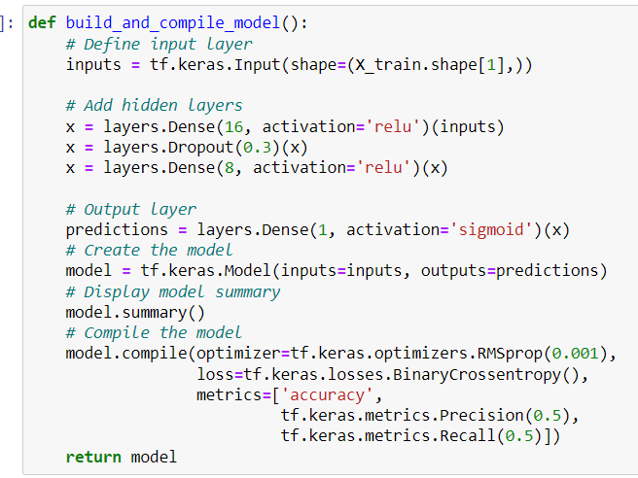

This function `build_and_compile_model` constructs a simple neural network model and compiles it using TensorFlow's Keras API. Let's break down the steps:

1. **Input Layer**: The function defines an input layer with the shape corresponding to the number of features in the training data.

2. **Hidden Layers**: Two dense hidden layers are added with 16 and 8 neurons, respectively, both using ReLU (Rectified Linear Unit) activation functions. Additionally, a dropout layer with a dropout rate of 0.3 is applied after the first hidden layer. Dropout is a regularization technique used to prevent overfitting by randomly setting a fraction of input units to 0 during training.

3. **Output Layer**: The output layer consists of a single neuron with a sigmoid activation function. Sigmoid activation is commonly used in binary classification problems, as it squashes the output values between 0 and 1, representing the probability of the sample belonging to the positive class.

4. **Model Compilation**: The model is compiled using the RMSprop optimizer with a learning rate of 0.001. RMSprop is an adaptive learning rate optimization algorithm. The loss function is set to binary crossentropy, suitable for binary classification tasks. Additionally, accuracy, precision, and recall metrics are specified for model evaluation. The precision and recall metrics are calculated with a threshold of 0.5, which means they will be computed based on the predictions with probabilities greater than 0.5.

ReLU (Rectified Linear Unit) and sigmoid functions are commonly used activation functions in machine learning.

1. **ReLU (Rectified Linear Unit)**:

- The ReLU function is a simple non-linear activation function defined as \( f(x) = \max(0, x) \).

- It returns zero if the input is less than zero and the input itself if it's greater than or equal to zero.

- ReLU has become very popular in deep learning due to its simplicity and effectiveness in combating the vanishing gradient problem.

- ReLU activation allows models to learn faster and perform better on large datasets compared to traditional activation functions like sigmoid or tanh.

2. **Sigmoid Function**:

- The sigmoid function is a smooth, S-shaped curve function defined as \( f(x) = \frac{1}{1 + e^{-x}} \).

- It squashes the input values between 0 and 1, making it suitable for binary classification problems where the output is a probability.

- Sigmoid activation is commonly used in the output layer of binary classification models because it can represent the probability that a given input belongs to a certain class.

- However, sigmoid can suffer from the vanishing gradient problem, especially in deep neural networks, where the gradients can become very small, making learning slow.

Both ReLU and sigmoid functions are used in different scenarios in machine learning models depending on the nature of the problem, the architecture of the neural network, and the desired characteristics of the activation function.

Softmax is another activation function used primarily in the output layer of neural networks, especially in multi-class classification problems. It is an extension of the sigmoid function and is used to transform the raw output of a neural network into probabilities that sum up to 1.

The softmax function takes a vector of arbitrary real-valued scores (usually the output of the last layer of a neural network) and transforms them into probabilities proportional to the exponentials of these scores. Mathematically, the softmax function is defined as

The softmax function essentially amplifies the scores to make large values larger and small values smaller, while ensuring that the resulting values sum up to 1, thus representing a probability distribution over the classes.

Softmax is commonly used as the final activation function in multi-class classification problems because it allows the model to output probabilities for each class, making it straightforward to interpret the model's predictions and compare them against ground truth labels.

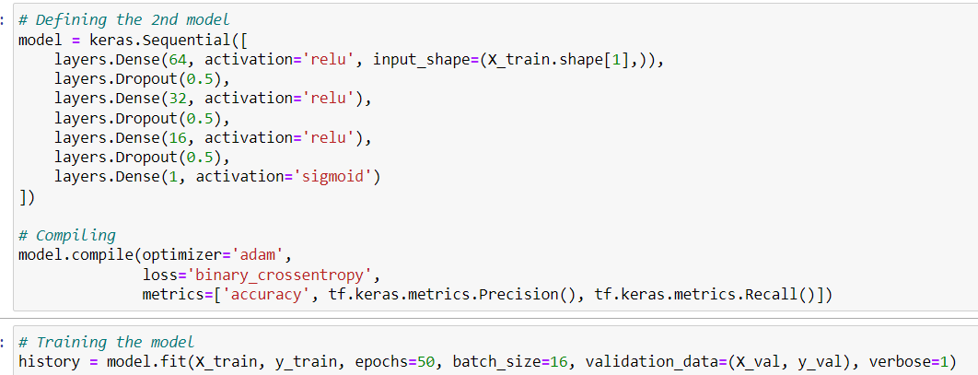

This code defines a neural network model using the Keras API with TensorFlow backend. Let's break down what each part does:

1. **Sequential Model**: This model represents a linear stack of layers.

2. **Layers**:

- `Dense`: These are fully connected layers. Each layer has a specified number of units (neurons). The first layer (`Dense(64, activation='relu', input_shape=(X_train.shape[1],))`) has 64 units and uses ReLU activation function. It also specifies the input shape, which is inferred from the shape of the training data `X_train`. Subsequent layers (`Dense(32, activation='relu')`, `Dense(16, activation='relu')`, `Dense(1, activation='sigmoid')`) also use ReLU activation except for the last layer, which uses the sigmoid activation function.

- `Dropout`: These layers apply dropout regularization, which randomly sets a fraction of input units to zero during training to prevent overfitting. The dropout rate is specified as 0.5, meaning half of the input units will be dropped randomly during each training iteration.

3. **Compilation**:

- `optimizer='adam'`: Adam is an optimization algorithm that is commonly used for training deep learning models. It adapts the learning rates for each parameter during training.

- `loss='binary_crossentropy'`: This is the loss function used during training. It is commonly used for binary classification problems. Binary cross-entropy measures the difference between the true labels and the predicted probabilities.

- `metrics`: These are the metrics used to evaluate the model's performance during training and testing. In this case, the metrics include accuracy, precision, and recall.

Overall, this model consists of three hidden layers with ReLU activation and dropout regularization, followed by an output layer with a single neuron and sigmoid activation, suitable for binary classification tasks.

Iteration 2

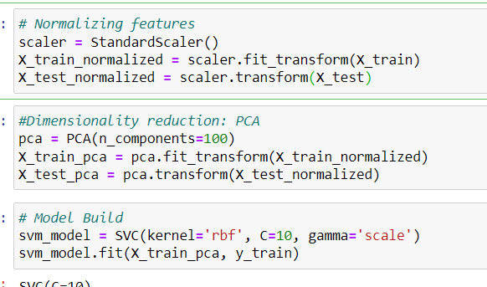

This code snippet demonstrates a typical machine learning pipeline, including feature normalization, dimensionality reduction using Principal Component Analysis (PCA), and model training using Support Vector Machine (SVM).

Let's break down the steps:

1. **Feature Normalization**:

- The `StandardScaler` from scikit-learn is used to normalize (standardize) the features. This step is crucial for algorithms that are sensitive to feature scales, such as SVM.

- `X_train_normalized` and `X_test_normalized` store the normalized training and testing features, respectively.

2. **Dimensionality Reduction (PCA)**:

- Principal Component Analysis (PCA) is applied to reduce the dimensionality of the dataset.

- `PCA(n_components=100)` specifies that PCA should reduce the dimensionality to 100 principal components.

- `X_train_pca` and `X_test_pca` store the transformed training and testing features, respectively, after PCA.

3. **Model Building (SVM)**:

- The Support Vector Machine (SVM) model is instantiated with certain hyperparameters (`kernel='rbf'`, `C=10`, `gamma='scale'`).

- `kernel='rbf'` specifies that the SVM should use the radial basis function (RBF) kernel.

- `C=10` specifies the regularization parameter.

- `gamma='scale'` specifies the kernel coefficient for 'rbf' as \( \frac{1}{\text{number of features}} \).

- The model is then trained on the PCA-transformed training data using `svm_model.fit(X_train_pca, y_train)`.

This pipeline is a common approach in machine learning workflows. Feature normalization ensures that all features have a similar scale, which is important for many algorithms, including SVM. Dimensionality reduction with PCA helps to reduce the computational complexity of the model while preserving most of the variance in the data. Finally, the model is trained on the transformed data.

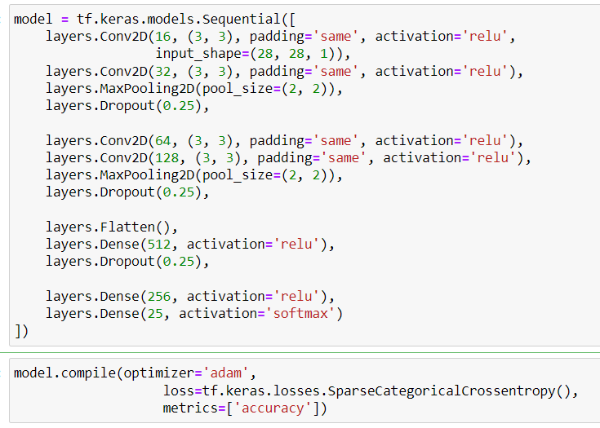

This code defines a convolutional neural network (CNN) model using the Keras API with TensorFlow backend for image classification. Let's dissect the model:

1. **Sequential Model**: This model represents a linear stack of layers.
2. **Convolutional Layers**:
   * **Conv2D**: These layers perform 2D convolutions, applying a specified number of filters to the input data.
   * The first convolutional layer (**Conv2D(16, (3, 3), padding='same', activation='relu', input_shape=(28, 28, 1))**) has 16 filters with a kernel size of 3x3, using ReLU activation. It also specifies the input shape as (28, 28, 1) for grayscale images.
   * Subsequent convolutional layers follow a similar pattern, increasing the number of filters (32, 64, 128) gradually, and using ReLU activation.
3. **Pooling Layer**:
   * **MaxPooling2D**: This layer performs max pooling operation to downsample the input representation, reducing its dimensionality.
   * It is applied after every pair of convolutional layers with a pool size of (2, 2).
4. **Dropout**:
   * **Dropout**: These layers apply dropout regularization to prevent overfitting. Dropout randomly sets a fraction of input units to zero during training.
   * It is applied after each max pooling layer and after the dense layers.
5. **Flattening**:
   * **Flatten**: This layer flattens the input, converting it into a one-dimensional array, before feeding it into the dense layers.
6. **Dense Layers**:
   * **Dense**: These are fully connected layers. The first dense layer (**Dense(512, activation='relu')**) has 512 units with ReLU activation.
   * The second dense layer (**Dense(256, activation='relu')**) has 256 units with ReLU activation.
   * The last dense layer (**Dense(25, activation='softmax')**) has 25 units (assuming it's a classification task with 25 classes) with softmax activation, which outputs a probability distribution over the 25 classes.
7. **Compilation**:
   * **optimizer='adam'**: Adam optimizer is used for optimization.
   * **loss=tf.keras.losses.SparseCategoricalCrossentropy()**: Sparse categorical cross-entropy loss function is used for multi-class classification. La2en 0 to 8 then 10 to 24 mafi 9=j.
   * **metrics=['accuracy']**: Accuracy is used as the evaluation metric during training and testing.

This CNN architecture is suitable for image classification tasks, leveraging convolutional and pooling layers to extract features from images and dense layers for classification.

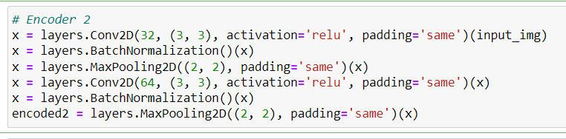

This code defines an encoder portion of a convolutional autoencoder using Keras with TensorFlow backend. Let's break it down step by step:

1. **Convolutional Layer**:
   * **layers.Conv2D(32, (3, 3), activation='relu', padding='same')(input_img)**: This layer applies 32 filters of size 3x3 to the input image (**input_img**) using the ReLU activation function. Padding is set to 'same', meaning the output size is the same as the input size.
2. **Batch Normalization**:
   * **layers.BatchNormalization()(x)**: Batch normalization is applied after the first convolutional layer. Batch normalization normalizes the activations of the previous layer, which can help with training stability and speed.
3. **Max Pooling Layer**:
   * **layers.MaxPooling2D((2, 2), padding='same')(x)**: This layer performs max pooling with a pool size of 2x2, reducing the spatial dimensions of the input by half. Padding is set to 'same', which means the output size will be adjusted to maintain the same spatial dimensions as the input.
4. **Convolutional Layer (Second Stack)**:
   * **layers.Conv2D(64, (3, 3), activation='relu', padding='same')(x)**: Another convolutional layer is applied with 64 filters of size 3x3, followed by ReLU activation and 'same' padding.
5. **Batch Normalization (Second Stack)**:
   * **layers.BatchNormalization()(x)**: Batch normalization is applied after the second convolutional layer.
6. **Max Pooling Layer (Second Stack)**:
   * **layers.MaxPooling2D((2, 2), padding='same')(x)**: Another max pooling layer is applied to further reduce the spatial dimensions by half.
7. **Encoded Output**:
   * **encoded2**: The output of the second max pooling layer represents the encoded representation of the input image. This is the compressed representation learned by the autoencoder.

This encoder architecture progressively reduces the spatial dimensions of the input image while increasing the number of filters, capturing increasingly abstract features.

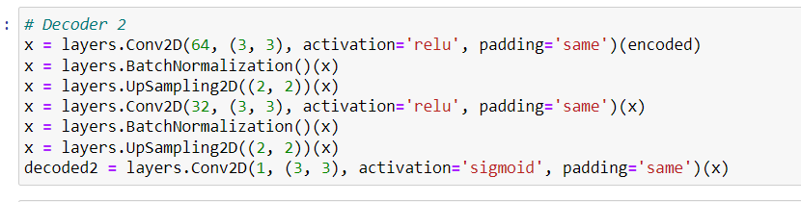

This code defines a decoder portion of a convolutional autoencoder using Keras with TensorFlow backend. Let's go through it step by step:

1. **Convolutional Layer**:
   * **layers.Conv2D(64, (3, 3), activation='relu', padding='same')(encoded)**: This layer applies 64 filters of size 3x3 to the encoded input (**encoded**) using the ReLU activation function. Padding is set to 'same' to maintain the output size.
2. **Batch Normalization**:
   * **layers.BatchNormalization()(x)**: Batch normalization is applied after the convolutional layer to normalize the activations.
3. **UpSampling Layer**:
   * **layers.UpSampling2D((2, 2))(x)**: This layer performs upsampling of the input by repeating rows and columns. Here, each dimension of the input is doubled.
4. **Convolutional Layer (Second Stack)**:
   * **layers.Conv2D(32, (3, 3), activation='relu', padding='same')(x)**: Another convolutional layer is applied with 32 filters of size 3x3, followed by ReLU activation and 'same' padding.
5. **Batch Normalization (Second Stack)**:
   * **layers.BatchNormalization()(x)**: Batch normalization is applied after the second convolutional layer.
6. **UpSampling Layer (Second Stack)**:
   * **layers.UpSampling2D((2, 2))(x)**: Another upsampling layer is applied to further increase the spatial dimensions.
7. **Decoded Output**:
   * **decoded2**: The output of the last convolutional layer represents the decoded output of the autoencoder. The activation function used is sigmoid, which squashes the output values between 0 and 1, making it suitable for reconstructing images.

This decoder architecture progressively increases the spatial dimensions of the input while decreasing the number of filters, ultimately reconstructing an image that closely resembles the original input. The final output (**decoded2**) is the reconstructed image.

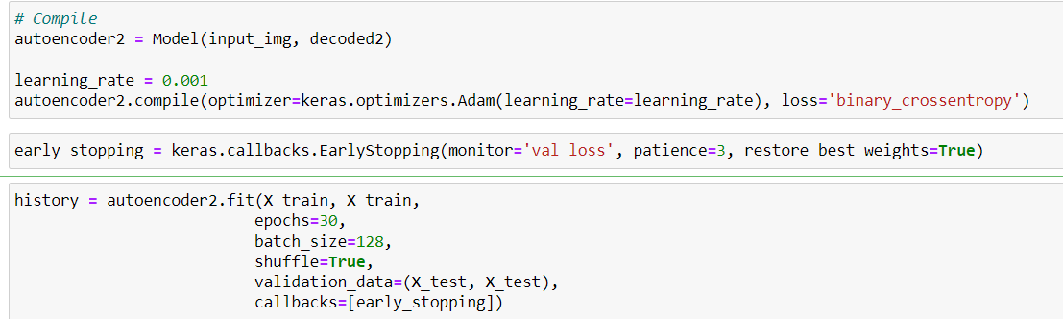

This code compiles and trains the autoencoder model you've defined earlier. Here's what each part does:

1. **Compile**:
   * **autoencoder2 = Model(input_img, decoded2)**: This line creates the autoencoder model using the previously defined encoder and decoder parts.
   * **learning_rate = 0.001**: Sets the learning rate for the Adam optimizer.
   * **autoencoder2.compile(optimizer=keras.optimizers.Adam(learning_rate=learning_rate), loss='binary_crossentropy')**: Compiles the autoencoder model. It uses the Adam optimizer with the specified learning rate and binary cross-entropy loss function. Since the output is binary (values between 0 and 1), binary cross-entropy is used as the loss function.
2. **Early Stopping**:
   * **early_stopping = keras.callbacks.EarlyStopping(monitor='val_loss', patience=3, restore_best_weights=True)**: This sets up early stopping, which monitors the validation loss and stops training if it doesn't improve after a certain number of epochs (3 in this case). **restore_best_weights=True** restores the best weights found during training.
3. **Model Training**:
   * **history = autoencoder2.fit(X_train, X_train, epochs=30, batch_size=128, shuffle=True, validation_data=(X_test, X_test), callbacks=[early_stopping])**: This trains the autoencoder model. It uses the training data **X_train** both as input and target output. It runs for a maximum of 30 epochs with a batch size of 128. The data is shuffled during training. Validation data **(X_test, X_test)** is provided to monitor the performance of the model during training. The **callbacks** argument includes early stopping to prevent overfitting.

After training, the training history (**history**) will contain information about the training and validation loss at each epoch, which can be used for visualization and further analysis.



This code performs spectral clustering on a dataset using different numbers of clusters (k) ranging from 2 to 9. It computes the silhouette score for each value of k, which is a metric used to evaluate the quality of the clustering.

Here's what each part of the code does:

1. **Import Libraries**:
   * **from sklearn.cluster import SpectralClustering**: This imports the SpectralClustering class from the scikit-learn library, which is used to perform spectral clustering.
   * **from sklearn.metrics import silhouette_score**: This imports the silhouette_score function from scikit-learn, which computes the silhouette score for a clustering.
2. **Loop Over Different Numbers of Clusters**:
   * **for k in range(2, 10):**: This loop iterates over different numbers of clusters, ranging from 2 to 9.
3. **Spectral Clustering**:
   * **spectral = SpectralClustering(n_clusters=k, random_state=42)**: This initializes the spectral clustering algorithm with the current value of k.
   * **labels = spectral.fit_predict(df_pca)**: This fits the spectral clustering algorithm to the data (**df_pca**) and assigns each data point to a cluster. The resulting cluster labels are stored in the **labels** variable.
4. **Compute Silhouette Score**:
   * **silhouette_scores.append(silhouette_score(df_pca, labels))**: This computes the silhouette score for the current clustering result and appends it to the list **silhouette_scores**. The silhouette score measures the compactness and separation of the clusters, with higher values indicating better clustering.

After running this code, the **silhouette_scores** list will contain the silhouette scores for spectral clustering with different numbers of clusters. You can analyze these scores to determine the optimal number of clusters for your dataset. Typically, you would choose the number of clusters that maximizes the silhouette score.

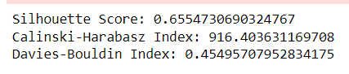

The silhouette score, Calinski-Harabasz index, and Davies-Bouldin index are metrics used to evaluate the quality of clusters obtained from clustering algorithms. Here's what each of these metrics represents:

1. **Silhouette Score**:
   * The silhouette score measures how similar an object is to its own cluster (cohesion) compared to other clusters (separation).
   * It ranges from -1 to 1, where a high value indicates that the object is well matched to its own cluster and poorly matched to neighboring clusters.
   * A score close to 1 indicates dense and well-separated clusters.
2. **Calinski-Harabasz Index**:
   * Also known as the variance ratio criterion, it computes the ratio of dispersion between clusters to dispersion within clusters.
   * Higher values of the Calinski-Harabasz index indicate better-defined clusters.
   * It is computed as the ratio of the sum of between-cluster dispersion and the sum of within-cluster dispersion.
3. **Davies-Bouldin Index**:
   * This index evaluates the average similarity between each cluster and its most similar cluster, where similarity is measured in terms of the ratio of within-cluster distances to between-cluster distances.
   * Lower values of the Davies-Bouldin index indicate better clustering.
   * The index is minimized when clusters are dense and well-separated.

Based on the values you provided:

* Silhouette Score: 0.655
  + This indicates that the clustering has produced well-separated clusters with objects being closely matched to their own clusters and poorly matched to neighboring clusters.
* Calinski-Harabasz Index: 916.40
  + A high value suggests that the clusters are well-defined and distinct from each other.
* Davies-Bouldin Index: 0.455
  + This low value indicates that the clusters are dense and well-separated.

Overall, these metrics suggest that the clustering has produced good-quality clusters with clear separation between clusters and objects being well-matched to their respective clusters.